**Test For Sendme Data Scientist**

Thank you for applying to Sendme Inc. Your application was impressive, and the next stage of the interviews would be a data cleaning / data processing test case.

The test attached in this document will test the following criteria

* Ability to use Python Data science libraries
* Ability to solve the base test case and extend to other solutions
* Ability to write structured Python code
* Ability to use Jupyter notebook.

**TEST CASE:**

Mr. Bamidele started an e-commerce store in 2020. When he started his business, he began taking orders and keeping records in a single row of an excel sheet.. He has however hired you to sort all his orders into an organized order format.

Please find the raw data set below

[Raw Data](https://docs.google.com/spreadsheets/d/19yyYg2G4K_fTVdCAW7SHVB88WyoyjSXo69GV-VZoNE8/edit?usp=sharing)

The data should be organised into the following columns

* Date
* Order Time
* Item/Items
* Address
* Name
* Contact
* Amount
* Delivery Time

Also find a picture of the organised format below,

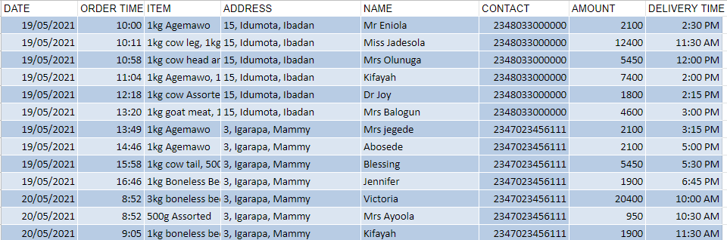

Your role as a Data Scientist is to write a script that can go through the data sample and then return the data in an organized format.

Please Note: Submission is in 48-72hrs. Please add devops@sendme to your private Github repository and reply to this email.

If you have any questions, Please reach out in the email thread,

Best of Luck.